First go the local folder in your windows and copy the directory:

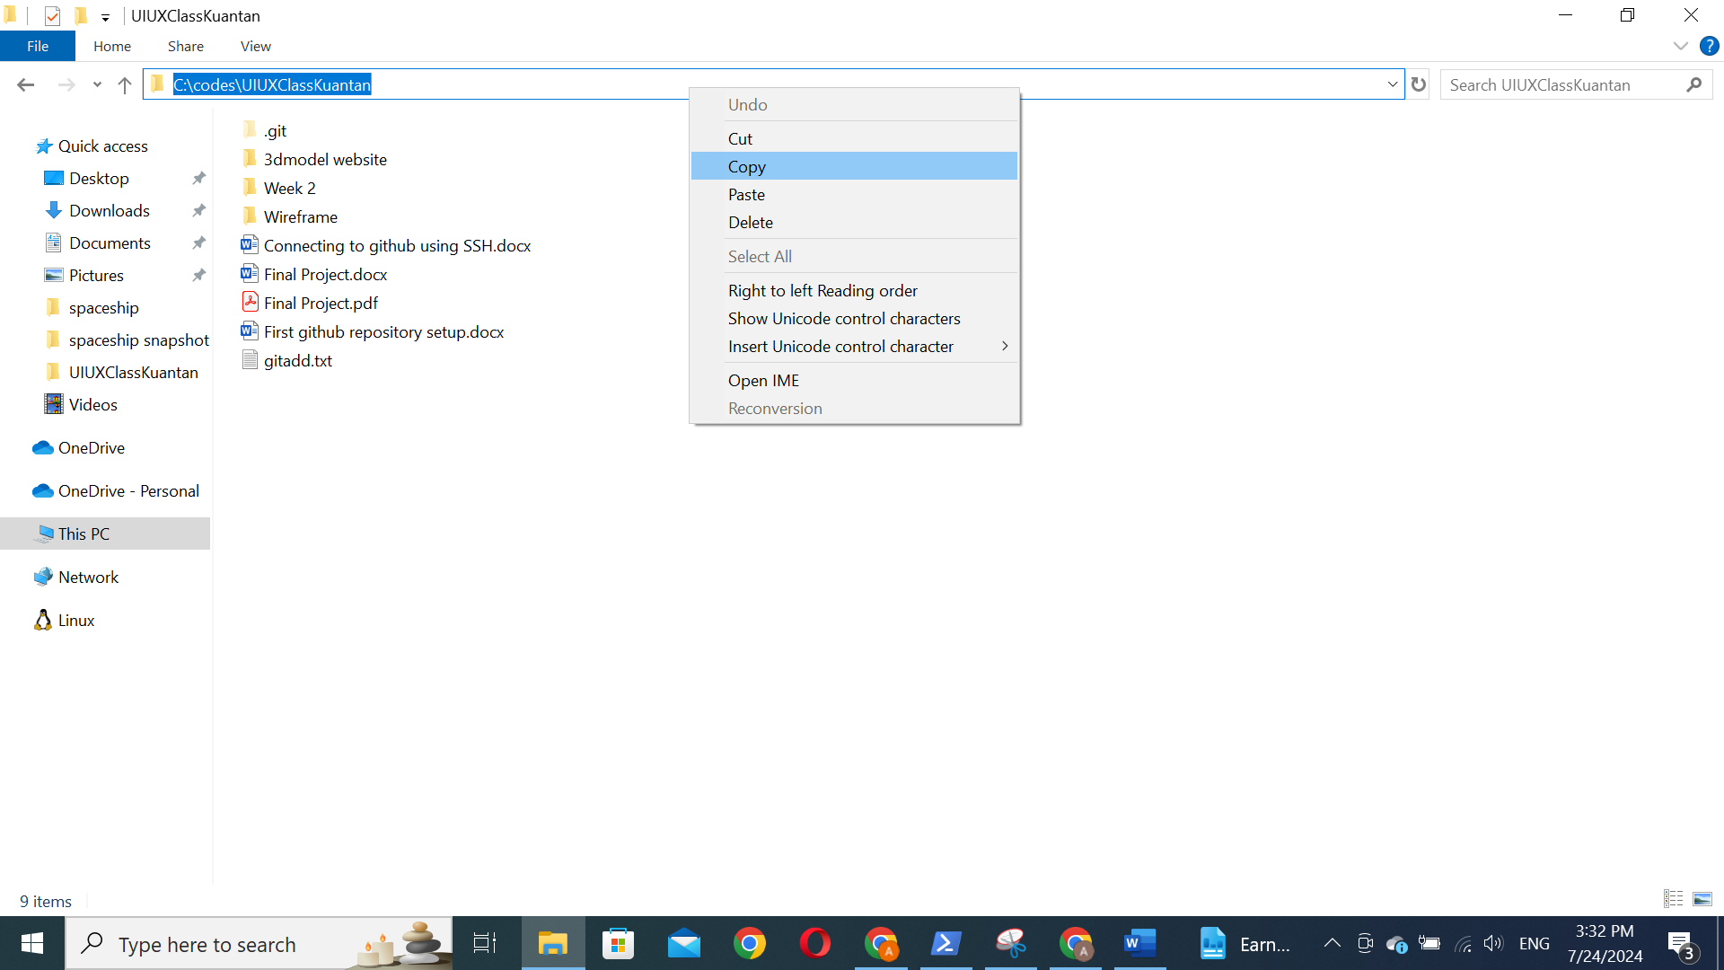

Then change the directory of the PowerShell using:

cd directory

for example for me is cd C:\codes\UIUXClassKuantan

